Queries:

CREATE INDEX Contact_Index ON Student (ContactNumber ASC);

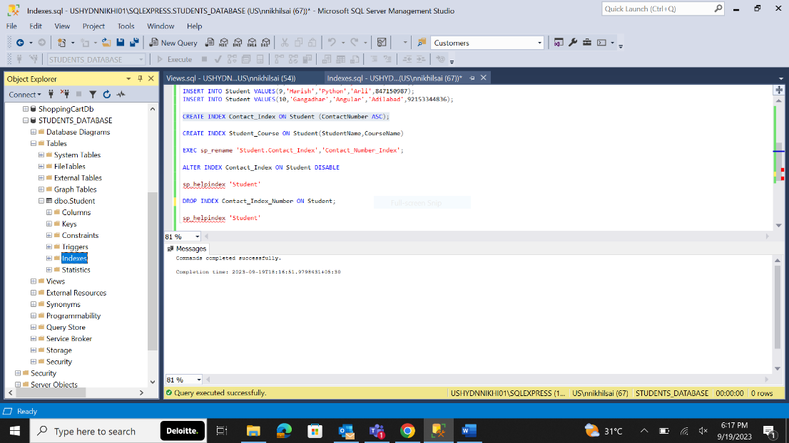

CREATE INDEX Student_Course ON Student(StudentName,CourseName)

EXEC sp_rename 'Student.Contact_Index','Contact_Number_Index';

ALTER INDEX Contact_Index ON Student DISABLE

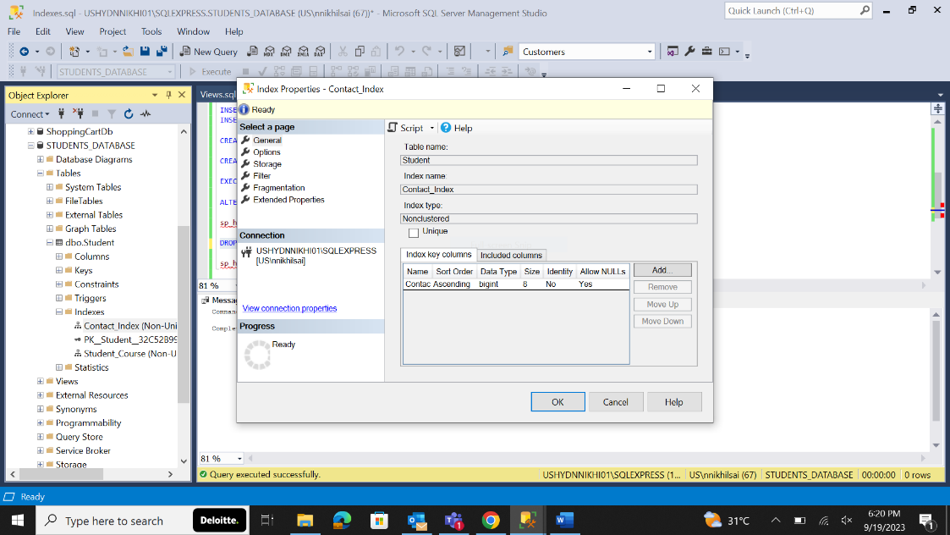

sp_helpindex 'Student'

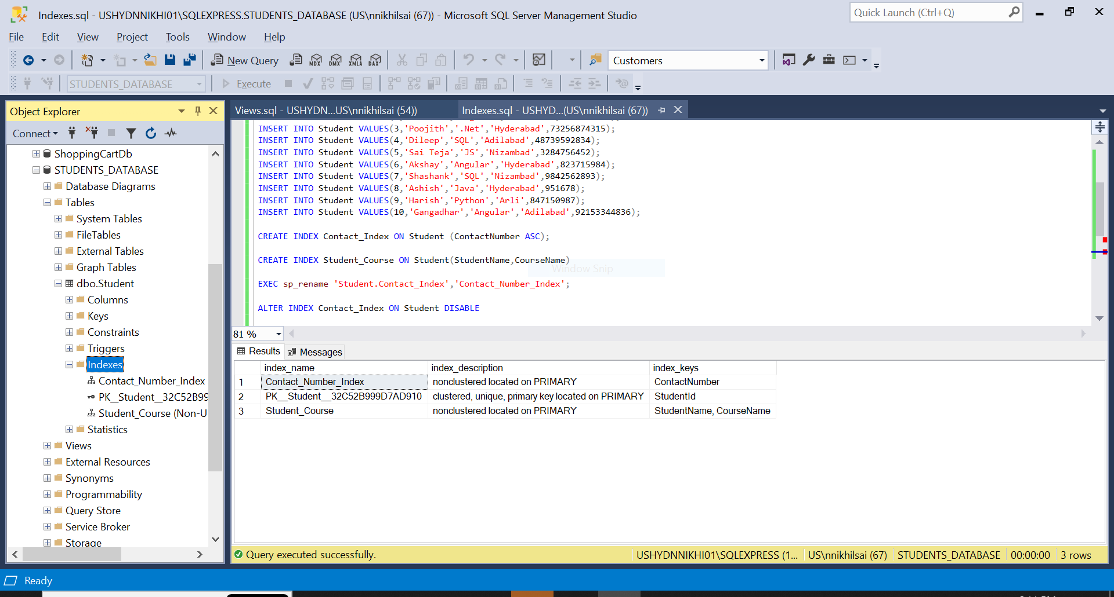

DROP INDEX Contact_Index_Number ON Student

